**CT870 Internet Programming (20 marks)**

**Assignment 2:** Bootstrap

**Due date:** Sunday Oct 10th

**Redesign your previous club website to make aspects of it responsive according to the following instructions**

**Step1**: Please create a new Firebase project for this assignment, **don’t** overwrite your existing assignment 1.

In this assignment you are tasked with redesigning your existing web application for a fictitious online club and you are free to re-use the content from it, such as images, text etc.

This link to the documentation for Bootstrap <https://getbootstrap.com/docs/5.1/> will contain everything you need to help you with this assignment. I’d recommend using the search feature on the top left of the documentation to find key information to help you below.

**index.html**

1. The index.html page should now include Bootstrap via either a CDN link or locally by downloading them and relatively linking to them. (see Bootstrap video and notes on Blackboard if you don’t know how to include it via CDN) Done
2. You should use a **Bootstrap** **card** tocontain your **news and updates** content and a **separate** card to contain the **match fixtures and results.** Ensure each card has a **specific body and title (see Bootstrap card examples on the online documentation for this).** These cards should be positioned vertically on the page, i.e. they should not be side by side.
3. The **Images** of the chairperson of the club, the secretary and treasurer should also be placed in a single **card** on the page, placed below the first two. The three pictures should be placed side by side in a single **row** with each image 4 columns wide. Ensure the card has a **title and a body**.
4. You should use the **figure and figcaption tags** with specific Bootstrap classes designed for handling figures (see Bootstrap figures example in docs) in each of their respective columns. Ensure that the text captions under each image, such as chairman, secretary and treasurer are centred (see Fig 1 for example).
5. Due to space constraints on smaller devices the club owners have requested that this card should be invisible on extra small devices but visible on all other screen sizes. This can be achieved using the **display property in Bootstrap**

**Submission Instructions:**

1. On Blackboard you can enter in the URL of your web page deployed on Firebase.

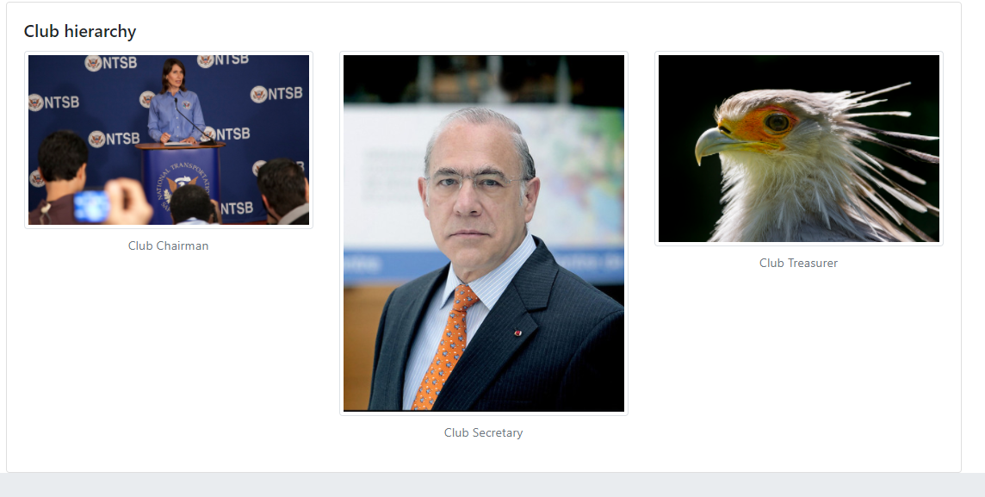

Figure Sample of what part 3 and 4 could look like